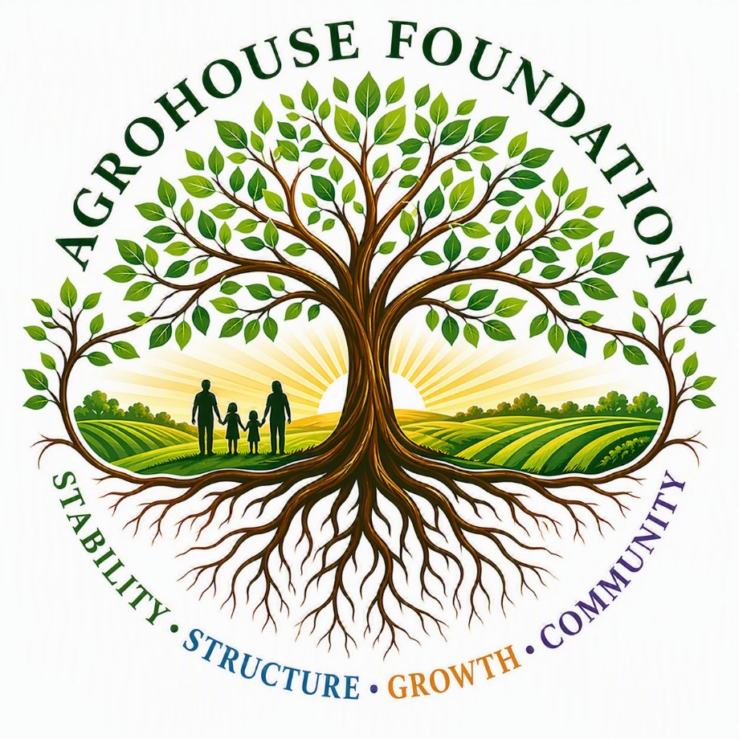
Agrohouse foundation™
Board Member Onboarding Packet
June 27, 2026
Agrohouse foundation
8733 McKendree Rd, Wesley Chapel, FL 33545

